*Desert Classic All Arabian Horse Show*

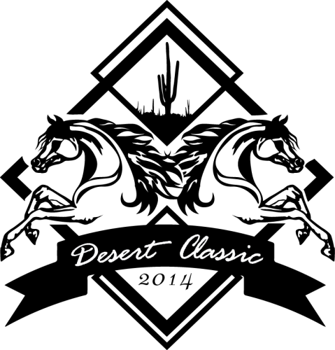

PLEASE TYPE OR PR

2

# Dec. 5-8, 2024 WestWorld Scottsdale, AZ

Do Not Use this Entry Form for Academy Classes. Academy entry form available on page 32-33 and at [www.desertclassicshow.com](http://www.desertclassicshow.com/)

MAIL TO:

Nancy Harvey

490 E. Montecito Ave Sierra Madre, CA 91024 Phone: 626-390-8918

INT/ ONLY ONE HORSE PER ENTRY FORM. All entries must be complete. Enclose copies of horse registration papers, purchase contract (if applicable), AHA, USEF/EC ,USDF Membership cards, amateur certification for each rider, driver, handler, coach, trainer, owner and correct fees. ONE HORSE PER ENTRY FORM

|  |  |  |  |  |  |  |  |  |  |  |  |  |  |  |  |  |  |  |  |  |  |  |
| --- | --- | --- | --- | --- | --- | --- | --- | --- | --- | --- | --- | --- | --- | --- | --- | --- | --- | --- | --- | --- | --- | --- |
| No. | Name of Horse | | | | | | | | Registration # | | | | | | | | Date of Birth | | Sex | | Color | Height |
| Sire | | | | Dam | | | | | | | | | | Horse USEF ID | | | | Horse USDF # | | | |
| Rider 1 | Classes/Sections |  |  |  | |  | |  | |  | | |  |  | |  | |  | | **TOTAL FEES** | | |
| Entry Fees |  |  |  | |  | |  | |  | | |  |  | |  | |  | | **$** | | |
| Rider/Driver/Handler Name | | | | | | | | | DOB MM/DD/YY | | | Amateur Certificate  Yes No | | | Rider’s relationship to owner(s) for owner classes | | | | | | | |
| AHA # |  | USEF/EC # | |  |  |  | USDF# | | |  |  |  |  |  | Safe Sport | | |  | |  |  |  |
| Address |  |  | |  |  | City |  | | |  |  |  |  |  | State | | | Zip | |  |  |  |
| Rider 2 | Classes/Sections | |  |  | |  | |  | |  | | |  |  | |  | | **TOTAL FEES** | | | | |
| Entry Fees | |  |  | |  | |  | |  | | |  |  | |  | | **$** | | | | |
| Rider/Driver/Handler Name | | | | | | | | | DOB MM/DD/YY | | | Amateur Certificate Yes No | | | Rider’s relationship to owner(s) for owner classes | | | | | | | |
| AHA # |  | USEF/EC # | |  |  |  | USDF# | | |  |  |  |  |  | Safe Sport | | |  | |  |  |  |
| Address |  |  | |  |  | City |  | | |  |  |  |  |  | State | | | Zip | |  |  |  |
| Rider 3 | Classes/Sections |  |  |  | |  | |  | |  | | |  |  | |  | |  | | **TOTAL FEES** | | |
| Entry Fees |  |  |  | |  | |  | |  | | |  |  | |  | |  | |  | | |
| Rider/Driver/Handler Name | | | | | | | | | DOB MM/DD/YY | | | Amateur Certificate  Yes No | | | Rider’s relationship to owner(s) for owner classes | | | | | | | |
| AHA # |  | USEF/EC # | |  |  |  | USDF# | | |  |  |  |  |  | Safe Sport | | |  | |  |  |  |
| Address |  |  | |  |  | City |  | | |  |  |  |  |  | State | | | Zip | |  |  |  |
| OWNER (as appears on reg. papers or contract)  Name AHA # If joint owner check one Non Related Co-Owner Related (see above) AHA# USEF/EC# USDF#  Farm/Ranch USEF/EC # E-Mail USEF Farm # Address USDF # City, State, Zip Email Cell Phone TRAINER (reverse must be signed by owner if there is no trainer)  Name AHA # Address USEF/EC # City USDF# State , Zip Email Email Cell Phone  Payment Information Check # (Make checks payable to Desert Classic)  Card # Exp. Date Verification # (last 3 numbers on back of card) Name on Card  Signature  I agree to all Terms and Conditions, including a 5% processing fee  Billing Address | | | | | | | | | | | **Total Class Entry Fees $___________**  **_____ Horse Stalls $155 (no shavings) $___________**  **_____ Tack Stalls $155 (no shavings) $___________**  **_____ Office Fee $50 per horse $___________ Postmarked by November 15, 2024**  **_____ Office Fee $70 per horse $___________ Postmarked after November 15, 2024**  **_____ Post entry fee $5 per class $___________**  **_____ Grounds Fee $50 per horse per day $___________**  **_ AHA Single Event Membership Fee**  **$40 per person $___________**  **_____ AHA Show Fee $7 per horse $___________**  **_____ AHA 9-90 Res. Fee $5 per horse $___________**  **_____ USEF Federation Fee $23 per horse $___________ ($8 USEF, $15 D&M**  **_____ WDAA Non-Member Show Pass $___________**  **$45 Per Adult, $30 per Junior**  **_____ Class Sponsorships $___________**  **$25 Regular, $50 Championship**  **_____ Trail/Dress Equip Fee $15/horse $___________**  **_____ Hunt/Jump Equip Fee $15/horse $___________**  **_____ VSAHA/AHA Member Discount $___________**  **$25 per owner**  **SUB TOTAL FEES $___________ Processing Fee with Card, add 5% of total $___________ TOTAL FEES ENCLOSED $___________**  **Please do not prorate fees**  **OFFICE USE ONLY: Amount Paid___________ Date______** | | | | | | | | | | | |

MINOR EXHIBITOR CONSENT and EMERGENCY CONTACT INFORMATION SEE REVERSE SIDE OF ENTRY FORM

**Stable with:_____________________________________**

AHA ENTRY AGREEMENT

I have read the rules concerning competitions as printed in the Arabian Horse Association (AHA) Handbook/Directory and Competition Prize List and agree to be bound by

and subject to those rules.

AHA ASSUMPTION OF RISK, RELEASE AND INDEMNIFICATION This document waives very important legal rights. Read it carefully before signing. In consideration for AHA permitting me to participate in this Competition, and by signing the entry blank, I agree as follows:

I AGREE that I choose to participate voluntarily in this Competition as a rider, driver, handler, lessee, owner, agent, coach, trainer, junior exhibitor or as a parent or guardi- an of a junior exhibitor. I AM FULLY AWARE AND ACKNOWLEDGE THAT HORSE SPORTS AND PAFRTICIPATION IN THIS COMPETITION INVLOVE SERIOUS RISK OF HARM INCLUDING BUT NOT LIMITED TO RISK OF ACCIDENT, SERIOUS BODILY INJURY, INCLJUDING DEATH, BROKEN BONES, HEAD INJURIES, TRAUMA, PAIN AND SUFFERING, AND PROPERTY DAMAGE. I ASSUME ALL RISKS OF HARM TO ME, MY HORSE OR MY PROPERTY.

I AGREE, *as a horse show participant (or parent/guardian of participant if a minor) to waive all claims which may otherwise arise from, including but not limited to infec- tious bacteria, viruses, fungi/mold, parasites or other agents which may be present at the Horse Show (and most other outdoor locations) and can cause infections in humans as well as in animals.*

I AGREE for myself, my heirs, executors, administrators, successors and assigns to release AHA , the Competition, the facilities leased by the Competition and the owner

(s) of the facilities and all of their respective officers, officials, directors, employees, agents, personnel, volunteers, affiliated organizations and insurers (collectively, the “Released Parties”) from any and all claims for damage, loss or injury to myself, other persons, horses or other property belonging to me to the fullest extent permitted by law that arises out of or relates in any way to the Competition and my participation in the Competition INCLUDING BUT NOT LIMITED TO DAMAGES. LOSS OR INJURY RESULTING FROM ANY ACTS, FAILURE TO ACT,M NEGLIGENCE OR NEGLECT OF OTHER ENTRANTS, THE RELEASED PARTIES, THEIR CONTRACTORS OR INVITEES, as well

as for theft, vandalism, fire, other casualty damage or damages arising from any defects in the premises.

I AGREE to indemnify and hold harmless (that is pay all losses, damages, attorneys fees and cost of) the Released Parties from and against any and all claims, demands, penalties, actions, losses, costs, damages, injuries, liabilities and obligations (including attorneys fees) of whatsoever kind and nature which may be asserted against or incurred by any of them as a result of (1) my participation on the Competition or (2) any act, failure to act or neglect (a) by me, my agents, employees, riders, handlers, trainers, coaches, drivers, contractors or invitees or (b) by any animal owned or exhibited by me or in my custody or control.

I AGREE and represent that I am qualified and eligible to enter and/or participate in the Competition and every horse I am entering is qualified and eligible as entered.

I AGREE to accept AS FINAL any decision of AHA, the Show Commission, or Show Officials concerning my qualification or the qualification of my horse to enter the Compe- tition or any results of the Competition, except to the extent that the rules of AHA, the Competition, EC or USEF Equestrian permit a protest or hearing of such decisions. Should a hearing be requested, I agree to accept AS FINAL the decision of the particular hearing body. I agree to release, hold harmless and not to sue AHA, the Competi- tion sponsor, their officers, directors, employees, volunteers, or members concerning any decision of AHA, the Competition, its Show Commission, Show Officials or any hearing body that relates to my qualifications or my horse(s) qualifications to enter the competition or any results of the Competition.

I AGREE that AHA has the sole right to control, sell, supervise or give away (or assign to others the right to do so) the exclusive rights to broadcast, televise, reproduce, transmit and disseminate all or part of this event, and I agree that AHA may use or assign, in any way AHA sees fit, photographs, films, videos, audios, cablecasts or other likenesses of me and my horse taken during the course of the Competition for the promotion, coverage or benefit of the Competition or AHA. Those likenesses shall not be used to advertise a product and they may not be used in such a way which implies endorsement of any company, product, product category or service. I hereby expressly and irrevocably waive any rights in connection with such use, including any claim to compensation, invasion of privacy, right of publicity or to misappropriation.

By signing below as a parent or guardian of a junior exhibitor, I consent to the child’s participation and agree to all of the above provisions, and further agree to assume all of the obligations of this AHA Assumption of Risk, Release and Indemnification personally and on behalf of the child.

This AHA Assumption of Risk, Release and Indemnification is governed by the Laws of the State of Colorado and is intended to be interpreted as broadly as possible. I agree that exclusive jurisdiction and venue (place) for any legal action against AHA, its officers, directors, employees, volunteers or agents shall be in the local district courts or the federal court of the State of Colorado. If any part of this agreement is determined to be unenforceable, all other parts shall remain in effect.

USEF FEDERATION ENTRY AGREEMENT

By entering a Federation-licensed Competition and signing this entry blank as the Owner, Lessee, Trainer, Manager, Agent, Coach, Driver, Rider, Handler, Vaulter or Longeur and on behalf of myself and my principals, representatives, employees and agents I agree that I am subject to the Bylaws and Rules of the United States Eques- trian Federation, Inc (the “Federation”) and the local rules of the Arabian Horse Association and this Competition. I agree to be bound by the Bylaws and Rules of the Federation and of the Competition. I will accept as final the decision of the Hearing Committee on any question arising under the Rules, and agree to release and hold harmless the competition, the Federation, their officials, directors and employees for any action taken under the rules. I represent that I am eligible to enter and/or par- ticipate under the Rules and every horse I am entering is eligible as entered. I also agree that as a condition of and in consideration of acceptance of entry, the Federation and/or the Competition may use of assign photographs, videos, audios, cable-casts, broadcasts, internet, film, new media or other likenesses of me and my horse taken during the course of the competition for the promotion, coverage or benefit of the Competition, sport or the Federation. Those likenesses shall not be used to advertise a product and they may not be used in such a way as to jeopardize amateur status. I hereby expressly and irrevocably waive and release any rights in connection with such use, including any claim to compensation, invasion of privacy, right of publicity or to misappropriation. The construction and application of Federation rules are governed by the State of New York and any action instituted against the Federation must be filed in New York State. See GR908.4.

BY SIGNING BELOW, I AGREE that I have read, understand and agree to be bound by all applicable Federation Bylws, rules and policies including the USEF Safe Sport Policy and Minor Athlete Abuse Prevention Policies (MAAPP) as published at [www.usef.org,](http://www.usef.org/) as amended from time to time, as well as all terms and provisions of this Prize List. If I am signing and submitting this Agreement electronically I acknowledge that my electronic signature shall have the same validity force and effect as if I affixed my signature by my own hand.

|  |  |  |
| --- | --- | --- |
| Owner **Mandatory Must be Adult | Print  Name | **Adult  Signature |
| Trainer or Custodian of Horse at show  **Mandatory Must be Adult | Print Name | **Adult Signature |
| Rider 1 **Mandatory Must be Adult | Print Name | **Adult Signature |
| Rider 2 **Mandatory Must be Adult | Print Name | **Adult Signature |
| Rider 3 **Mandatory Must be Adult | Print Name | **Adult Signature |
| Coach (if applicable USEF#) | Print Name | **Adult Signature |
| Print Minor | Print Parent/Guardian Name Here | **Adult Signature |
| Print Minor | Print Parent/Guardian Name Here | **Adult Signature |
| Print Minor | Print Parent/Guardian  Name Here | **Adult  Signature |
| EMERGENCY PHONE NUNBER FOR EXHIBITOR | | |

**Junior/Youth Address City State Zip Date of Birth**

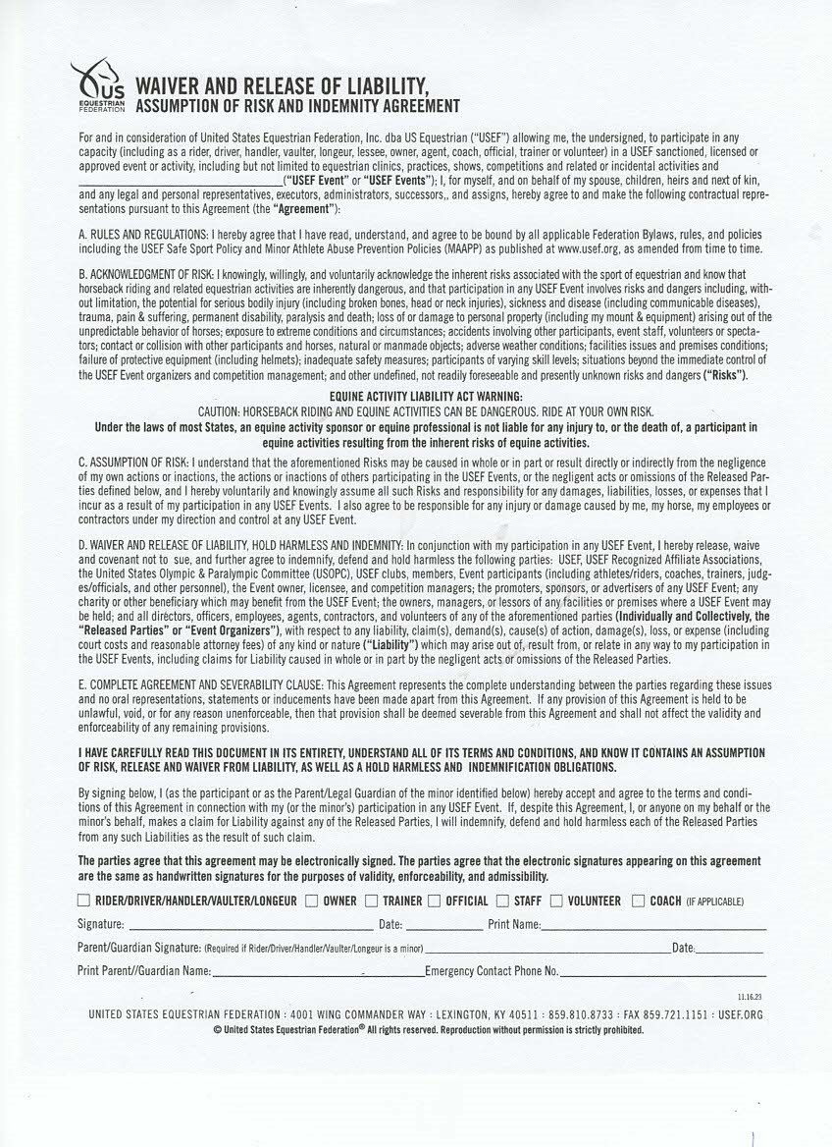

**REQUIRED INFO: Back # and Horse’s Name**

Desert Classic Horse Show